**Experiment No.:** 0

**Experiment Name:** Implementation of Linear regression of function approximation.

**Theory:**

Linear regression is a numerical method used to approximate a given function or relationship between a dependent variable y and an independent variable x. In simple linear regression, the model assumes a straight-line relationship between xxx and y, represented as:

y= a0 + a1 * x

Where:

* a1​ is the slope of the line (regression coefficient),
* a0​ is the intercept on the y-axis.

The goal of linear regression is to determine the values of a0​ and a1​ such that the line best fits the given data points. This is achieved by minimizing the **sum of squared errors (SSE)** between the observed values and the predicted values from the regression line.

Mathematically, the coefficients are obtained using the **least squares method**, defined as:

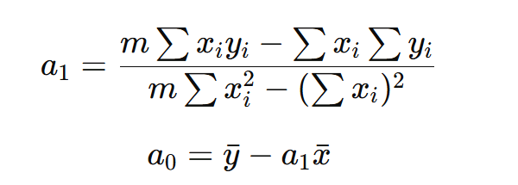

The accuracy of the regression model can be evaluated by computing the **Mean Squared Error (MSE)**, given by:

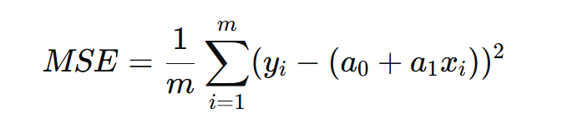

Linear regression is widely used for **function approximation**, **data trend analysis**, and **predictive modeling**, as it provides a simple and effective way to estimate relationships between variables.

**Program 1:** Programming Code

import numpy as np

import matplotlib.pyplot as plt

x = np.array([0, 1, 2, 3, 4, 5])

y = np.array([2.5, 2.9, 4.6, 5.5,6.1, 7.9])

m = **len**(x)

sum_x = np.sum(x)

sum_y = np.sum(y)

sum_xy = np.sum(x * y)

sum_x2 = np.sum(x ** 2)

a = (m * sum_xy - sum_x * sum_y) / (m * sum_x2 - sum_x ** 2)

b = (sum_y - a * sum_x) / m

**print**(f"Coefficients: a = {a}, b = {b}")

plt.scatter(x, y, *color*='blue', *label*='Data points')

plt.plot(x, a * x + b, *color*='red', *label*='Fitted line')

plt.grid()

plt.title('Least Squares Fit')

plt.legend()

plt.show()

**Output:**

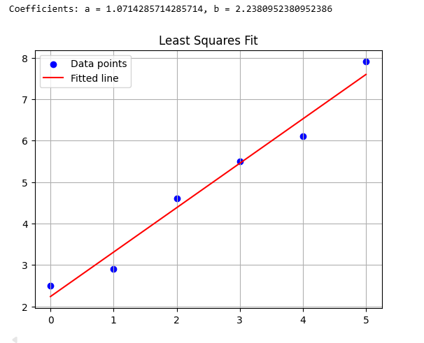

**Discussion & Conclusion**

The Linear Regression method effectively approximates the relationship between dependent and independent variables by fitting a straight line using the least squares principle. It minimizes the squared differences between observed and predicted values, providing the best linear fit for given data points.

In conclusion, this method proved to be simple, accurate, and efficient for function approximation when the data shows a linear trend. It serves as a fundamental technique in numerical analysis and predictive modeling, offering reliable results with minimal computation.